Corrosion Protection of Steel Rebar in Concrete using Migrating Corrosion Inhibitors, MCI 2021 & 2022

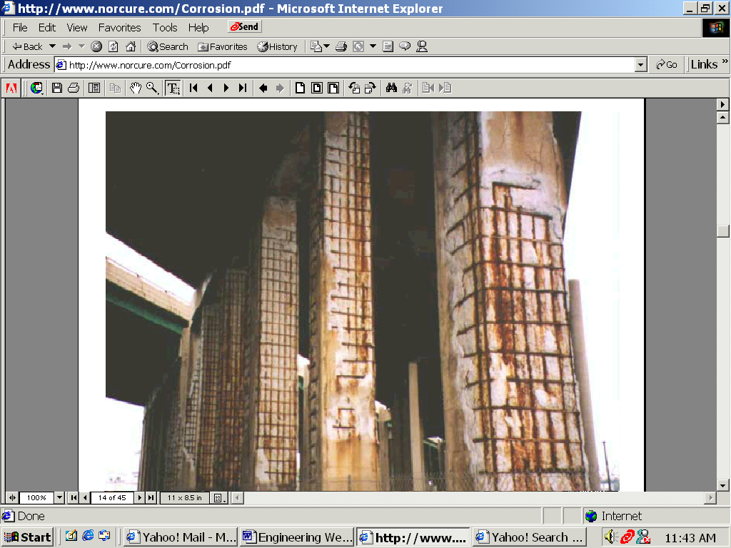

Prepared for:
The Cortec Corporation
4119 White Bear Parkway
St Paul, MN 55110
(Report #1136)

Prepared by:

Behzad Bavarian, PhD
Professor of Materials Engineering

Lisa Reiner
Graduate Research Assistant
Dept. of Manufacturing Systems Engineering & Management
College of Engineering and Computer Science
California State University, Northridge
March 2002



CALIFORNIA STATE UNIVERSITY NORTHRIDGE
The effectiveness of two commercially available migrating corrosion inhibitors (MCI 2021 and 2022) for steel rebar in concrete was investigated and the results compared with untreated concrete. Ten concrete specimens with varying densities were prepared with reinforcement placed at 1 inch (2.5 cm) concrete coverage and tested over a period of 380 days. Theoretically, high density concrete impedes corrosive species from reaching the surface of the rebar. It may also prevent the inhibitor from reaching the surface of the concrete. Electrochemical monitoring techniques were applied while samples were immersed in 3.5% NaCl at ambient temperatures. Due to the low conductivity of concrete, the corrosion behavior of steel rebar had to be monitored using AC electrochemical impedance spectroscopy (EIS). During this investigation, changes in the resistance polarization and the corrosion potential of the rebar were monitored to ascertain the degree of effectiveness for these MCI products. The results were compared with previous investigations conducted on several admixtures and stainless steel rebar. X-ray photoelectron spectroscopy (XPS) and depth profiling were used to check if the inhibitors reacted with the rebar surfaces.

The experimental results demonstrated that the MCI products offered protection for the steel rebar and show promise as an inhibiting system in aggressive environments like seawater. The MCI 2022 and MCI 2021 products proved to be more effective in the low-density concrete samples and MCI 2022 had better corrosion protection than MCI 2021. X-ray photoelectron spectroscopy (XPS) analysis demonstrated the presence of inhibitor on the steel rebar surface, indicating that the MCI migrated through the concrete layer. The XPS depth profiling showed the presence of a 100 nm layer amine-rich compound on the rebar surface; this corresponded with the increase in the R_{p} values and improved corrosion protection for the steel rebar treated with MCI.

INTRODUCTION
Corrosion of reinforcing steel in concrete structures, when exposed to chlorides, is a common occurrence. It is a complex phenomenon related to structural, physical, chemical and environmental considerations. Much effort has been focused on the design of new structures to reduce or eliminate corrosion through increased concrete coverage using reduced permeability concrete or replacing the steel reinforcement with alternative materials. However, little effort has been made in establishing reliable techniques for the repair of existing structures. Since many of the structures built after WWII are reaching the end of their design life and there are no plans to replace them, a rehabilitation program is necessary. It was cited in a 1993 survey by the Strategic Highway Research Program in the United States that the cost to repair chloride induced deteriorated bridge decks was $20 billion and increasing at a rate of $500 million annually.

Reinforcing steel embedded in concrete shows a high amount of resistance to corrosion. The cement paste in the concrete provides an alkaline environment that protects the steel from corrosion. This corrosion resistance stems from a passivating or protective ferric oxide film that forms on the steel when it is embedded in concrete. This film is stable in the highly alkaline concrete (pH approx. 11-13). The corrosion rate of steel in this state is negligible. Factors influencing the ability of the rebar to remain passivated are the water to cement ratio, permeability and electrical resistance of concrete. These factors determine whether corrosive species like carbonation and chloride ions can penetrate through the concrete pores to the oxide layer on the rebar, then break down the passive layer, leaving the rebar vulnerable. Typically, concrete is cast without the inclusion of corrosive species. Chloride ions become available when the concrete is exposed to environmental factors, such as deicing salts applied to roads or seawater in marine environments.
Migrating Corrosion Inhibitor (MCI) technology was developed to protect the embedded steel rebar/concrete structure. These inhibitors can be organic or inorganic compounds; however organic compounds seem to be more effective (for neutralizing and film forming). Recent MCIs are based on amino-carboxylate chemistry¹⁻³. Normally, the most effective type of inhibitor lessens corrosion at the anodes and cathodes simultaneously. Organic inhibitors are a subgroup of the combined inhibitor. They utilize compounds that work by forming a monomolecular film between the metal and the water. These compounds are polar and have a strong affinity for surfaces onto which they may be adsorbed^{4, 12}. In the case of film-forming amines, one end of the molecule is hydrophilic and the other hydrophobic. These molecules will arrange themselves parallel to one another and perpendicular to the reinforcement such that a continuous barrier is formed. The presence of this film on samples of reinforcement encased in concrete with an organic inhibiting admixture has been shown by methods of ultraviolet spectroscopy and gas chromatography^{5.} These types of inhibitors are known as migrating corrosion inhibitors if they are able to penetrate into existing concrete to protect the steel in the presence of chloride⁶. The means by which the inhibitor migrates is first by diffusion through the moisture that is normally available in concrete, then by its high vapor pressure and finally by following hairlines and microcracks. This mechanism allows a greater amount to be applied where it is most needed. The diffusion process requires time to migrate through the concrete pores to reach the rebar’s surface and form a protective layer. This suggests that the migratory inhibitors are physically adsorbed onto the metal surfaces¹.
MCIs can be incorporated as an admixture or can be used by surface impregnation of existing concrete structures. With surface impregnation, diffusion transports the MCIs into the deeper concrete layers. They will delay and inhibit the onset of corrosion on steel rebar. Bjegovic and Miksic recently demonstrated the effectiveness of MCIs over five years of continuous testing¹⁻³. They also showed that the migrating amine-based corrosion-inhibiting admixture can be effective when they are incorporated in the repair process of concrete structures². Furthermore, laboratory tests have proven that MCI corrosion inhibitors migrate through the concrete pores to protect the rebar against corrosion even in the presence of chlorides³⁻⁴. However, the amount of additive inhibitor should be calculated based on the concrete chloride content. Chloride increases the level of conductivity of concrete⁷⁻⁹; it also breaks down the passive film from the steel reinforcement. The level of chloride ions required to initiate corrosion in concrete corresponds to 0.10% soluble chloride ion by weight of cement⁶⁻⁷. McGovern¹⁰ reports work by the United States Federal Highway Administration Laboratories that suggests the threshold value for steel corrosion as 0.20% acid-soluble chlorides by weight of cement. This is equivalent to between 0.6 and 0.8 kg of chlorides per cubic meter of concrete. The chloride threshold concentration is generally within 0.9 to 1.1 kg of chlorides per cubic meter of concrete¹¹.

The objective of this investigation was to study the corrosion inhibition of commercially available migrating corrosion inhibitors on steel rebar in three concrete densities. Theoretically, high density concrete impedes corrosive species from reaching the surface of the rebar. It may also prevent the inhibitor from reaching the surface of the concrete. Electrochemical monitoring techniques were applied while samples were immersed in 3.5% NaCl at ambient temperatures. Due to the low conductivity of concrete, the corrosion behavior of steel rebar had to be monitored using AC electrochemical impedance spectroscopy (EIS). During this investigation, changes in the resistance polarization and the corrosion potential of the rebar were monitored to ascertain the degree of effectiveness for these MCI products. The results were compared with previous investigations conducted on several admixtures and stainless steel rebar. X-ray photoelectron spectroscopy (XPS) and depth profiling were used to check if the inhibitors reacted with the rebar surfaces.

EXPERIMENTAL PROCEDURES
In theory, the steel rebar/concrete combination can be treated as a porous solution that can be modeled by a Randles electrical circuit. EIS tests performed on a circuit containing a capacitor and two resistors indicate that this model is an accurate representation of an actual corroding specimen. EIS testing allows for the determination of fundamental parameters relating to the electrochemical kinetics of the corroding system. This is attained through the application of a small amplitude-alternating potential signal of varying frequency to the corroding system. Because processes at the surface absorb electrical energy at discrete frequencies, the time lag and phase angle, theta, can be measured. The values of concern in this study are R_{p} and R_{Ω}. The R_{p} value is a measure of the polarization resistance or the resistance of the surface of the material to corrosion. R_{Ω} is a measure of the solution resistance to the flow of the corrosion current. By monitoring the R_{p} value over time, the relative effectiveness of the sample against corrosion can be determined. If the specimen maintains a high R_{p} value in the presence of chloride, it is considered to be "passivated" or immune to the effects of corrosion. If the specimen displays a decreasing R_{p} value over time, it is corroding and the inhibitor is not providing corrosion resistance.

The EG&G Instruments Potentiostat/Galvanostat Model 273A and EG&G M398 Electrochemical Impedance Software were used to conduct these experiments and to record the results. Bode and Nyquist plots were produced from the data obtained using the single sine technique. Potential values were recorded and plotted with respect to time. By comparing the bode plots, changes in the slopes of the curves were monitored as a means of establishing a trend in the R_{p} value over time. To verify this analysis, the R_{p} values were also estimated by using a curve fit algorithm on the Nyquist plots (available in the software).
Results from EIS tests were organized into bode and Nyquist plots. Based on these plots, the R_{p} and R_{Ω} combined values are displayed in the low frequency range of the bode plot and the R_{Ω} value can be seen in the high frequency range of the bode plot. The diameter of the Nyquist plot is a measure of the R_{p} value.

Concrete samples with dimensions 8” x 4” x 4” were prepared, and their densities were adjusted to achieve 130, 140, and 150 lb/ft³. Each sample consisted of one 8 inch steel (class 60) rebar (1/2” diameter) and one 8-inch Inconel metal strip (counter electrode). The rebar prior to being placed in concrete were exposed to 100% RH (relative humidity) to initiate corrosion. Concrete was mixed with one-half gallon water per 60-lb. bag (0.5 cement to water ratio) in a mechanical mixer. The concrete was vibrated by machine after being poured into the boxes. This was done to minimize bubbles and slurry. The coverage layer was maintained at one inch concrete for all these samples. These samples were cured for 28 days, their compressive strengths ranged between 2,700–3,000 psi. The concrete blocks were sandblasted to remove loose particles, leaving the concrete with a marginally smoother surface. MCI 2022 and MCI 2021 were applied to all but two of the concrete samples (used as a control). The samples were then immersed in 3.5 % NaCl solution (roughly 7 inches of each sample was immersed in the solution continuously). EIS (Electrochemical AC Impedance Spectroscopy) testing started 24 hours after immersing the samples. A Cu/CuS0₄ electrode was used as the reference and each sample was tested weekly. XPS analyses were performed on steel rebar that was in concrete treated with MCI, tested for 380 days, using KRATOS AXIS Ultra X-ray Photoelectron Spectrometer.

RESULTS and DISCUSSION

Corrosion Potentials
The corrosion inhibition of two commercially available migrating corrosion inhibitors (Cortec MCI 2022 and 2021) for three concrete densities was investigated over a period of 380 days using AC electrochemical impedance spectroscopy (EIS). Throughout this investigation, changes in the resistance polarization and the corrosion potential of the rebar were monitored to determine the degree of effectiveness for Cortec MCI 2021 & 2022 products. According to the ASTM (C876) standard, if the open circuit potential (corrosion potential) is -200 mV or higher, this indicates a 90% probability that no reinforcing steel has corroded. Corrosion potentials more negative than -350 mV are assumed to have a greater than 90% likelihood of corrosion. Figure 1 shows that corrosion potentials for all of the high density samples (HD2022-1, HD2022-2, HD untreated, HD2021-1, HD2021-2) were between the range of -400 mV to -600 mV after 128 days of immersion in NaCl. For the untreated control sample (L untreated), the corrosion potential was –295 mV at the end of testing. The corrosion potentials for MCI treated concrete samples (L2022-1, L2022-2, L2021-1) were between –120 to -145 mV. One of the samples (L2021-2) treated with MCI 2021 had a corrosion potential of -350 mV. Overall, the low density samples had significantly higher corrosion potentials, which translates to a greater likelihood of corrosion protection.

Resistance Polarization
Figure 2 shows that MCI treated concrete samples are increasing in their R_{p} values compared with the control samples that seem to have a decreasing trend. The high density concrete samples results were an exception. They showed rapid chemical deterioration; the MCI product did not have any effect on them. From the graph in Figure 2, the resistance polarization values at the end of testing were between 13,000 and 22,000 ohms for the low density concrete samples with MCI. The high density concrete showed much less corrosion inhibition with R_{p} values in the 1000 to 2000 ohm range. For non-treated samples (controls), the R_{p} value ended at 3170 ohms for low density samples and 1200 ohms for high density concrete. Changes in the R_{p} value were not immediately observed, indicating that corrosive species and/or Migrating Corrosion Inhibitors (MCIs) require an induction period for diffusion into the concrete.

Bode Plots
Figures 3-8 show the experimental results for low density (130 lb/ft³), high density (150 lbs/ft³) and untreated concrete samples. For each treatment, both samples from a given group show consistent results; in viewing the graphs, the curves are tightly spaced. In Figure 3, it is evident that there is a substantial difference between the low density and high density concrete samples. Unfortunately, the MCI products were not able to compensate for these differences as evidenced in Figures 6 and 7.

XPS Analysis
XPS analysis has demonstrated the presence of inhibitor on the steel rebar surface. The MCIs were able to penetrate through the concrete coverage layer to reach the rebar and impede corrosion. Figure 9 shows the XPS spectrum for the rebar removed from the MCI treated sample after 380 days. Figure 10 shows depth profiling results using 2 kV Ar⁺ ions for a steel rebar removed from MCI treated concrete; a 100 nm layer of amine-rich compound on the rebar surface was present. The XPS results showed the organic compound had carboxylate chemistry. Chloride was detected at about 0.10 atomic % and up to 50 nm on the top surface of the rebar. The XPS results demonstrate that both MCI and corrosive species had migrated in through the concrete pores, but MCI had managed to coat the surface and protect the steel rebar. The lower density samples coated with the MCI Inhibitor showed the greatest amount of corrosion resistance.¹³⁻¹⁴ The means by which the MCI inhibitor migrates into the concrete is first by diffusion through moisture that is normally available in concrete, then by its high vapor pressure and finally by following hairline and microcracks. Therefore, lower density concrete samples provide an easier path for the MCI inward diffusion, and faster corrosion retardation. These results are extremely promising for the MCI product in its ability to protect steel rebar in concrete in aggressive environments.

CONCLUSION
Corrosion inhibition of two commercially available migrating corrosion inhibitors (Cortec MCI 2022 and 2021) on steel rebar in concrete was investigated while the concrete was immersed in 3.5% NaCl at ambient temperatures using electrochemical monitoring techniques. The MCI products applied to low density concrete samples have successfully inhibited corrosion of the rebar for 380 days. Steel rebar corrosion potentials were maintained at approximately -145 mV, and rebar resistance polarization showed an increase reaching as high as 25,000 ohms (250% higher than the untreated rebar). However, the low density concrete has demonstrated better protection than the high density samples, a consequence of the migration mechanism for these inhibitors. XPS analysis showed the presence of inhibitor on the steel rebar surface verifying MCI migration through the concrete layer. Depth profiling showed 100 nm layer of amine-rich compound on the rebar surface, necessary for satisfactory corrosion resistance in the presence of chloride ions. In summary, the experimental results demonstrate that the MCI products offer an inhibiting system for protecting reinforced concrete in an aggressive 3.5% NaCl solution. These results show promise for the protection of steel rebar and concrete in aggressive environments.

Figure 9: XPS on MCI 2022 Treated Concrete after 378 days
Large area (1000 x 800um) survey scan from corroded surface

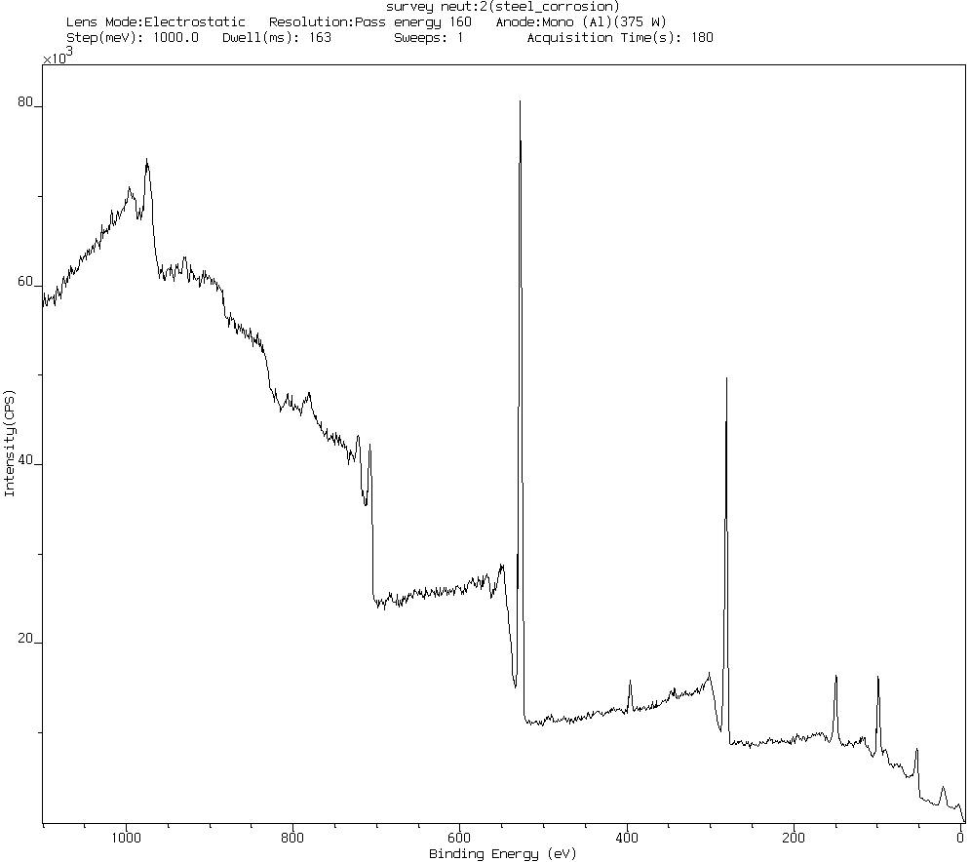
Fe 2p
Cu 2p
O 1s
N 1s
C
Si 2p
Si 2s
Cl 2p

Peak Position FWHM Raw Area RSF Atomic Atomic
BE (eV) (eV) (CPS) Mass Conc %

Fe 2p 710.400 4.101 5520.2 2.957 55.846 4.39
O 1s 531.200 3.021 10963.2 0.780 15.999 34.54
N 1s 398.500 2.187 416.3 0.477 14.007 2.24
C 1s 285.000 2.530 5401.2 0.278 12.011 50.34
Si 2p 101.800 2.575 1054.3 0.328 28.086 7.42
Cu 2p 935.250 1.410 656.1 5.321 63.549 0.27
Cl 2p 196.270 1.620 76.1 0.622 35.529 0.09

REFERENCES
- D. Bjegovic and B. Miksic, Migrating Corrosion Inhibitor Protection of
Concrete, MP, NACE International, Nov. 1999.
- D. Bjegovic and V. Ukrainczyk, “Computability of Repair Mortar with
Migrating Corrosion Inhibiting Admixtures,” CORROSION/97, paper no. 183
Houston, TX: NACE, 1997.
- D. Rosignoli, L.Gelner, and D. Bjegovic, “Anticorrosion Systems in the
Maintenance, Repair and Restoration of Structures in Reinforced Concrete,”
International Conference Corrosion in Natural and Industrial Environments: Problems and Solutions, Grado, Italy, May 23-25, 1995.
- D. Darling and R. Ram "Green Chemistry Applied to Corrosion and Scale Inhibitors." Materials Performance 37.12 (1998): 42-45.
- P.H. Emmons and V. M. Alexander "Corrosion Protection in Concrete Repair Myth and Reality." Concrete International 19.3 (1997): 47-56.
- D. Stark “Influence of Design and Materials on Corrosion Resistance of Steel in Concrete." Research and Development Bulletin RD098.01T. Skokie, Illinois: Portland Cement Association, 1989.
- W. Hime and B. Erlin. "Some Chemical and Physical Aspects of Phenomena Associated with Chloride-Induced Corrosion." Corrosion, Concrete and Chlorides: Steel Corrosion in Concrete: Causes and Restraints. Frances W. Gibson, Ed. Detroit, Michigan: American Concrete Institute, 1987.
- W.J. Jang and I. Iwasaki. "Rebar Corrosion Under Simulated Concrete Conditions Using Galvanic Current Measurements." Corrosion 47.11 (1991): 875-884.
- T. Liu and R. W. Weyers, "Modeling the Dynamic Corrosion Process in Chloride Contaminated Concrete Structures." Cement and Concrete Research 28.3 (1998): 365-379.
- M.S. McGovern "A New Weapon Against Corrosion." Concrete Repair Digest. June, 1994.
- R. Montani "Concrete Repair and Protection with Corrosion Inhibitor." Water
Engineering & Management 144.11 (1997): 16-21.
- C.K Nmai, S. A. Farrington, and G. S. Bobrowski. "Organic- Based Corrosion-Inhibiting Admixture for Reinforced Concrete." Concrete International 14.4, 1992.
- R. Martinez, A. Petrossian and B. Bavarian, “Corrosion of Steel Rebar in Concrete,” presented at the 12th NCUR, April 1998.
- L. Reiner and B. Bavarian, “Corrosion of Steel Rebar in Concrete,” presented at the 14th NCUR, Missoula, Montana, April 2000.

List of publications and presentations for
Corrosion Inhibition of Steel rebar in Concrete using MCI

SAMPE April 2001
ASM International, SFV Nov 2001
EUROCORR October 2001
CORROSION March 2001
Awards from NACE Southern California, Best Corrosion Research Project, Dec, 2001
CSUN/CSU Research Symposium, 1st place November 2000

Appendix

